**F. Y. B. Tech Academic Year 2021-22**

**Subject:** Programming and Problem Solving **Trimester:** 2

**Name:** Shreerang Mhatre  **Division:** 11

**Roll No:** 111056  **Batch:** K3

**ASSIGNMENT NO: 10**

**PROBLEM STATEMENT:** Write a Python function that accept a string and calculate the

number of uppercase and lowercase letter.

**OBJECTIVES:** To learn a functions in python.

**THEORY:**

**Function:**

A function is a block of code that only runs when it is called. Python functions return a value using a return statement, if one is specified. A function can be called anywhere after the function has been declared. By itself, a function does nothing

**Function used in the program:**

The function used in this program is string function. A string in Python is a sequence of characters. It is a derived data type. Strings are immutable. This means that once defined, they cannot be changed.

**Implementation:**

**Platform: 64 –**bit Windows 10**.**

**Technology:** Anaconda Navigator ( Jupyter Notebook )

**Algorithm:**

**Step1) Take a string from the user and store it in a variable.**

**Step2) Initialize the two count variables to 0.**

**Step3) Use a for loop to traverse through the characters in the string and**

**increment the first count variable each time a lowercase character is**

**encountered and increment the second count variable each time an**

**uppercase character is encountered.**

**Step4) Print the total count of both the variables.**

**Step5) Exit.**

**Anaconda Navigator:**

**Jupyter Notebook:**

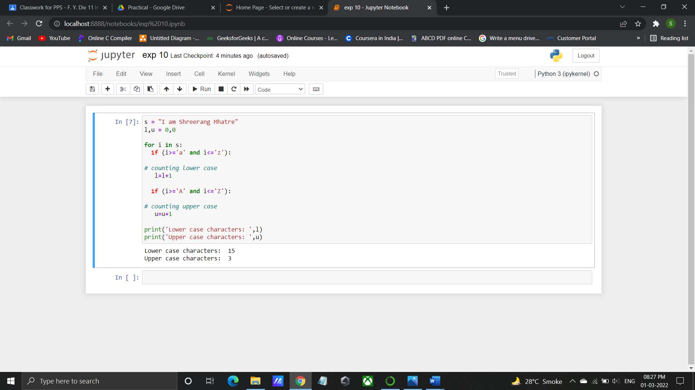

**Program/ Code:**

s = "I am Shreerang Mhatre"

l,u = 0,0

for i in s:

if (i>='a' and i<='z'):

# counting lower case

l=l+1

if (i>='A' and i<='Z'):

# counting upper case

u=u+1

print('Lower case characters: ',l)

print('Upper case characters: ',u)

**INPUT:** I am Shreerang Mhatre

**OUTPUT:** Lower case characters: 15

Upper case characters: 3

**CONCLUSION:** Thus, understood the function writing and in build functions

isupper(),islower() in Python

**FAQ:**

1. What isupper()function returns()?

ANS: isupper() is a built-in method used for string handling. This method returns True if all characters in the string are uppercase, otherwise, returns “False”.

1. What islower() function returns ()?

ANS: is a built-in method used for string handling. The islower() method returns True if all characters in the string are lowercase, otherwise, returns “False”. This function is used to check if the argument contains any lowercase characters.

1. What is function in python?

ANS: A function is a set of statements that take inputs, do some specific computation and produces output. The idea is to put some commonly or repeatedly done task together and make a function, so that instead of writing the same code again and again for different inputs, we can call the function. Python provides built-in functions like print (), etc. but we can also create your own functions. These functions are called user-defined functions.

1. Explain def keyword.

ANS: def is a keyword (case-sensitive) in python, it is used to define a function, it is placed before the function name (that is provided by the user to create a user-defined function). Syntax of def keyword def function_name: function definition statements.